Job Title | Optometry Adminstrative Assistant
Responsible to | Special Schools Eyecare Service Manager
Responsible for | Providing excellent management and administrative support to the SeeAbility special schools eye care service Manager

Our Values

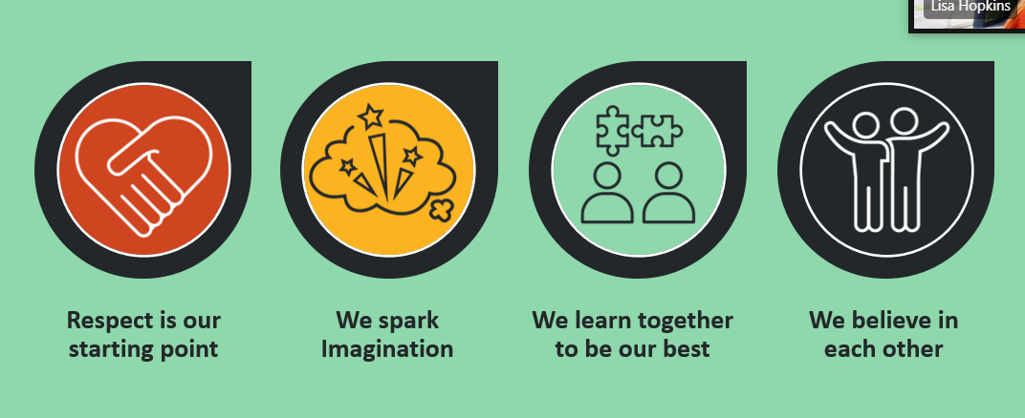

Your responsibilities
- With support from the Special Schools Service Manager and Supervisor to support the day to day running of the service including diary management, record keeping and liaising with parents and obtaining clinical consent forms.
- Managing incoming enquires by phone and email from parents and schools. Being first point of contact for general enquiries and signposting to clinicians where necessary.
- Liaising with schools on an ongoing basis to increase uptake for the service
- Securely storing completed consent/ eye care history forms
- Organising teachers training, coffee mornings or similar to increase parental uptake for the service.
- Being first point of contact for administrative tasks on the Practice Management System
- ​To ensure efficient and thorough record keeping, ensuring records are kept up to date and all interactions with children/families/carers/clinicians are recorded appropriately.

Your knowledge, experience, skills and values

Knowledge & qualifications | - Good knowledge and efficiency with Microsoft word/ outlook  - Satisfactory enhanced DBS check
Experience | - Experience in busy administrative environment.
Skills & personal attributes | - Excellent organisational skills.  - Ability to work independently and to own initiative.  - Excellent verbal and written communicator.  - Ability to manage own time efficiently and effectively.  - Strong IT and literacy skills  - Ability to maintain confidentiality.  - Confidence in communicating with children with complex learning and physical disabilities and their families and teachers.  - Acknowledge personal professional limitations and when to seek help and support and from which sources.  - Willingness and ability to travel extensively around Greater London and beyond as required.  - Good team player-willing to share knowledge and learn from others.  - Commitment to equal opportunities and diversity.

