Job Title | Quality Auditor
Responsible to | Head of Quality and Safeguarding
Responsible for | Quality-auditing the service we provide in our registered care homes and supported living environments; ad hoc reviews and investigations; assisting with CQC registration management.

Your Role
The factual bit
This role is full-time and home-based with a requirement to travel frequently.

Your role will involve:

- compliance and quality auditing and reviewing the services we provide to people living in our registered care homes and own homes (very often shared with others);
- auditing and reviewing by a combination of desktop assessment and home visits;
- reviewing and developing the processes by which we audit and review;
- supporting managers and their teams to improve;
- supporting managers and the organisation with CQC registrations;
- investigating concerns that arise, often with a safeguarding element;
- contributing to policy development and review; and,
- contributing to training programme development.

Our Values

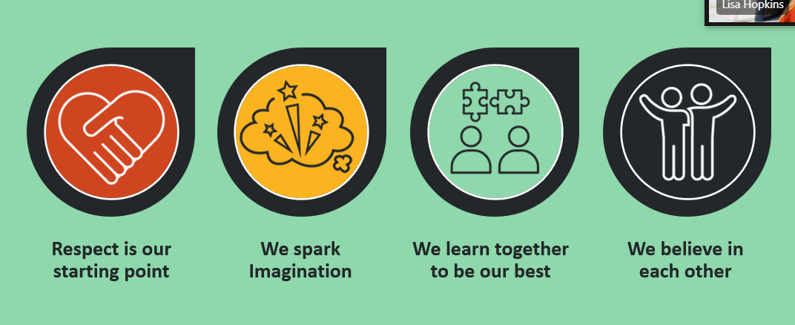

What you bring
You will bring to the role a good understanding of what excellent person-centred support looks like and share our ambition to see it delivered to all the people we support. Ideally, you will have developed this understanding by delivering high quality support yourself in the care sector, preferably to people who have autism or a learning disability.

You will have a good awareness of the legislation we and our regulators and commissioners work to. Areas of particular relevance include:
- The Care Act
- Health and Social Care Act
- Mental Capacity Act
- relevant Health & Safety regulations.

You will be familiar with the Care Quality Commission’s assessment framework and methods of working. You will also be familiar with the CQC’s registration processes and regulated activities relevant to our work. You will be confident in offering sound advice to colleagues based on this awareness but look always to empower managers.

You will be required to produce detailed thorough audit and investigation reports and to review policies and procedures, so must have excellent writing skills.

You will have excellent all-round administrative skills and work competently and confidently with Microsoft Office programmes, including Word, Excel and Powerpoint.

You will have first-class interpersonal skills for engaging with colleagues from all areas of the organisation and at all levels. You will be as comfortable performing formal presentations as you are talking to colleagues one-to-one, both virtually and in person.

You will have a can-do flexible approach and be able to manage a busy workload under pressure of deadlines. You will have a good understanding of what to prioritise when.

Your responsibilities
Using SeeAbility’s Quality Assurance Tool, you will audit the support our teams provide to people in a variety of registered care and supported living settings. You will promote managers’ use of this tool to self-assess and to action plan. And you will contribute to the further development of this tool.

You will work to a rolling programme of annual audits and reviews. This involves direct observation in the home as well as extensive desktop work. Additionally, you may be called upon to review services as and when the need arises.

You may play a role in helping improve performance where teams are found wanting. You will also lead on quality improvement-related workshops that we roll out to colleagues and contribute to the development of training packages.

You will need to develop a first-class awareness of our policies and procedures in order to support colleagues in their understanding of them. And you will contribute to policy and procedure review and development.

You will be called on to perform investigations. These may be investigations into individuals’ conduct, particularly when related to safeguarding concerns, or they maybe into team cultures.

You will assist in our management of CQC registrations.

You are expected to develop your own skills and knowledge by training and networking.

