Job Title | Apprentice Vision Rehabilitation Specialist
Responsible to | Lead Vision Rehabilitation Specialist
Responsible for | Vision Rehabilitation Team input in Surrey and Kent

Your Role
The Apprentice Vision Rehabilitation Specialist (AVRS) support people with a visual impairment, enabling, and empowering them to maximise opportunities to benefit/improve their quality of life.

Through personalisation, the apprentice will learn to provide specialist holistic assessments to the people we support, delivering individually tailored rehabilitation programs based upon assessment outcomes. To also provide a range of rehabilitative services to people with a visual impairment and their support teams/families to maximise independence and wellbeing. These outcomes will be identified and completed under supervision / guidance from a qualified VRS or the Lead VRS.

To enhance the skills and confidence needed to maximise people’s independence, whilst being an advocate for people with a visual impairment.

Your responsibilities
All employees are required to carry out other such duties as may reasonably be required to fulfil their role and support functional and organisational objectives.
Responsibilities associated with this job role:
- Managing your own case load under the supervision and guidance from a qualified VRS or Lead VRS in relation to vision rehabilitation input.
- Complete a range of assessments relating to the vision rehabilitative needs of people we support with guidance and/or supervision for a qualified VRS.
- Support SeeAbility's recommendation that everyone with a learning disability should have an eye test at least once a year and assist or provide information, training, and support with regards to this.
- Work closely with the Lead Vision Rehabilitation Specialist, Vision Rehabilitation Team, the wider Eye Care and Vision Team, Positive Behaviour Consultants and NHS services to provide a holistic model of support.
- Ensure, with the wider team, that the people we support have person centred support plans, informed by their visual abilities, needs and any adaptations or adjustments.
- Play an active role in ensuring the provision of the rehabilitative needs of everyone SeeAbility supports, working closely with managers the support staff etc (all Operational staff).
- Use initiative in problem solving and identifying potential new approaches to maximise people’s potential.
- Monitor and evaluate the rehabilitation elements of the service provided.
- Develop effective working relationships with support teams, families/circle of support to ensure best outcomes for people we support.
- Support the team in devising training packages. Implement and deliver these to support staff and other organisational colleagues.
- Provide information and advice to staff members regarding the rehabilitation requirements of people we support, including attendance at team meetings.
- Develop a high level of professional knowledge of philosophy; practice; relevant documents; research findings and visual impairment aids/adaptations.
- Attend / provide information to multi-disciplinary meetings, reviews, to advice on and advocate for, the developmental needs of people we support, including the sensitive understanding of the implications for people with visual loss.
- Comply with organisational policies.
- Promote the Vision and Values of the organisation.
- Engage in continuous personal development.

Your knowledge, experience, skills and values

Knowledge & qualifications | - Able to meet the travel requirements of the role by having access to a vehicle and hold a full UK driving licence, or alternative arrangements such as Access to Work for travel.  - Level 2 Maths and English (GCSE grade 4 or grade c)  Plus one of the following:  - Level 3 NVQ or Diploma or equivalent (full award)  - Level 3, 2 or more A levels or a BTEC National Diploma  - Level 2, NVQ or diploma (full award)  - Level 2, 5 GCSE passes at grade 4 (grade c) including Maths and English.  - Able to undertake any physical demands of the role including walking reasonable distances in all weather conditions.  - Knowledge of a range of services/resources or equipment available to people with a visual impairment.
Experience | - Experience of working with adults with learning disabilities/complex needs and visual impairments.  - Having completed all in-house Visual Impairment training.  - Experience of working with people, their families and support staff in teaching, coaching, training capacity.  - Can demonstrate understanding of person-centred practice.  - Can demonstrate ability to keep good, detailed records.
Skills & attributes | - Organisational skills  - IT skills – can operate Microsoft word, Excel, Outlook, iPlanet, Microsoft Teams  - Proven record of establishing effective working relationships with a variety of people  - Strong interpersonal skills to be able to gain the agreement and acceptance of others i.e. colleagues, senior managers.  - Effective communication skills (verbal and written)  - Supportive, respectful, conscientious, trustworthy, and considerate.  - Can deal with conflict.  - Can demonstrate a flexible approach to work.  - Ability to make decisions and solve problems, involving devising solutions and prioritising the resources available.  - Good time management skills.  - A high level of personal drive and commitment to high quality support and the ability to set an example for other staff.
Accountability | - Accountable for own performance and development  - Accountable for the quality of the work undertaken.  - Alert Lead Vision Rehabilitation Worker of issues that could affect performance.  - Assist the team to fulfil commitments and team performance needs  - Maintain effective working relationships and contribute to a working environment which is safe, considerate, and supportive to all, in accordance with relevant legislation and policy.  - Take reasonable care of your health, safety and welfare and that of other persons who may be affected by the performance of your duties.
Our Values:

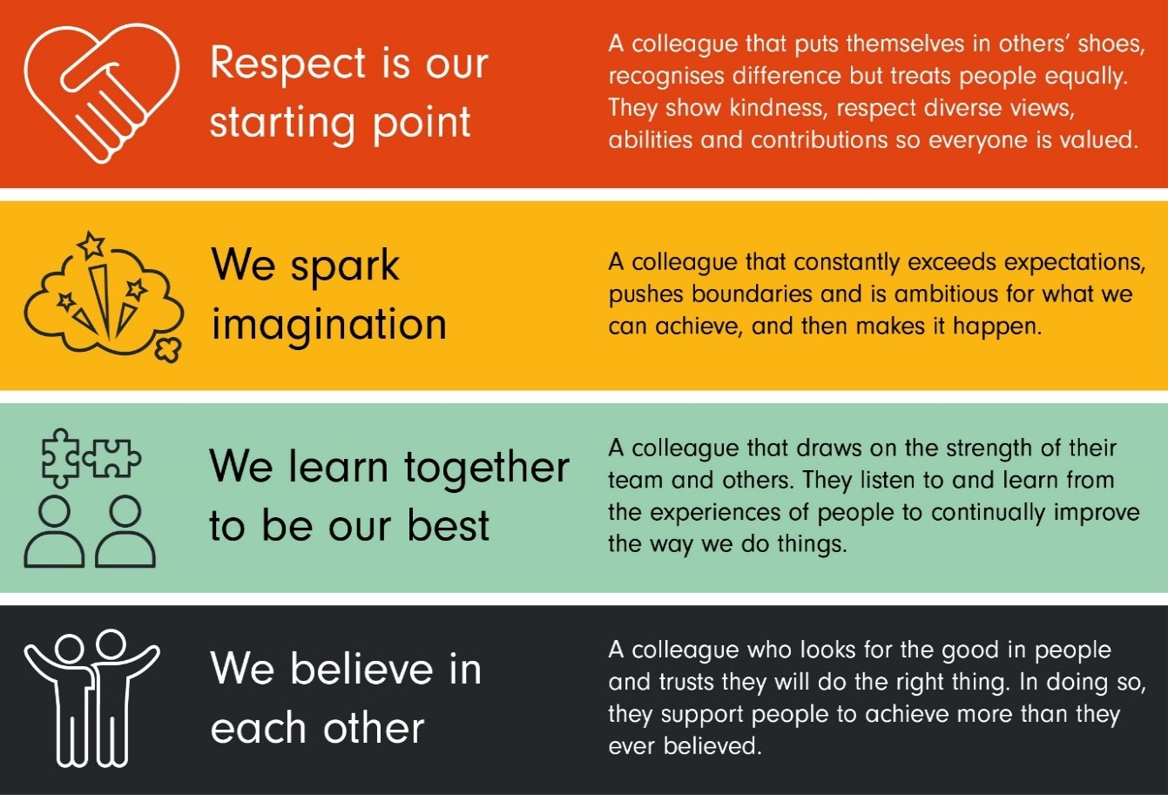

Notes:
It is the Charity’s policy to review Job Descriptions on an annual basis to ensure such duties contained herein continue to accurately reflect the requirements of the role. This Job Description will therefore be subject to change and development in line with the needs of the team/Charity. Any such changes will be discussed and agreed with the post holder.
The post holder is expected to be conversant with and work within the aims and objectives of the team and Charity and to adhere to current policies, practices and procedures.

