Job Title | Head of Business Development
Responsible to | Executive Director of Development
Responsible for | Achieving our ambitious growth forecast; identifying and securing new business opportunities for the charity.  Line management of two Development Managers

Your Role
This is an exciting time to be joining SeeAbility! We are about to embark upon our new five year strategy which will include ambitious goals to support more people to live independently and to participate and contribute as equal citizens in an inclusive society.

Our success will depend on us continuing to raise awareness of SeeAbility’s work and supporting more people to live great lives. In particular, we want to support more people who require a specialist support provider to live in their chosen community, away from Assessment and Treatment Units.

Our results show that the work we do at SeeAbility exceeds the expectation of our stakeholders and as a result we want more people to benefit from the great support we provide. It will be your job to help us with this goal; supporting more people with learning disabilities, autism and sight loss to Live, Love, Thrive and Belong. You will contribute to and co-ordinate business development activity including tender submissions, report writing and the maintenance of relevant databases. You will also coordinate referrals and work with the business development managers and operational team to ensure that all new homes are set up appropriately and meet the expectations of the people we support, families and our commissioners.

Our Values

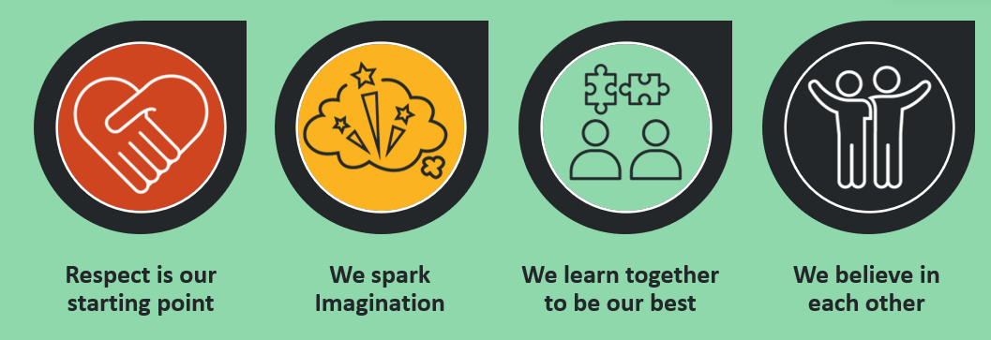

Your responsibilities

- Develop a strategy for identifying opportunities for SeeAbility to support more people, that complements the objectives within our 5-year strategy
- Personally develop relationships with key customers and stakeholders, by meeting regularly in a structured manner and reporting accordingly, to maintain an awareness of developments in the market that meet present business opportunities for existing homes and new developments.
- Ensure SeeAbility is known within its strategic areas whilst constantly reviewing the availability of new opportunities
- Liaise with local housing providers and manage strategic housing partnerships to establish a range of housing solutions for people
- In conjunction with operational colleagues, work to improve the quality of our external network of relationships with customers and influential organisations
- Become a key contributor in our Referrals and Assessment Decision Panel, where all new referrals are discussed
- Support Service Managers in the filling of empty rooms to maintain our high occupancy targets
- Ensure that all referrals are managed appropriately and in a timely manner in line with our referrals and assessment policy, working with Business Development Managers, operational colleagues and our Clinical Assessment and Intervention Team.
- Manage the referrals database and contribute to the analysis of data to inform future strategy.
- Work closely with relevant departments in the organisation with regards to tender demands and requirements.
- Manage tender presentations/submissions and contract negotiations. Analyse post submission feedback on tenders and ensure that lessons learnt are incorporated into new bids and tenders.
- Contribute to board reports on a quarterly basis
- Line manage two Development Managers
- Ensure all contracts with new and existing customers are commercially robust and that the contract value is maximised and risks reduced.
- Maintain awareness of own developmental needs and hence undertake training as necessary.
- As part of SeeAbility’s Leadership Group, take a key role in collaborating to deliver our 5-year strategy and building a one team culture.

Other
- Assist in maintaining a safe working environment and follow the requirements of SeeAbility’s Health and Safety Manual (policies and procedures) and any codes of set working practices.
- Carry out other duties commensurate with this post as requested by the Director of Development.
- Liaise effectively and efficiently with other departments and SeeAbility locations, undertaking tasks as required to support requests.
- Provide confidentiality at all times, working appropriately with sensitive documentation and in line with GDPR regulation.
- Adhere to all relevant regulatory guidelines.
Your knowledge and Experience
- Minimum of 3 years business development experience in a relevant sector
- Experience of working with people with learning disabilities and/or autism, their families and commissioners to successfully set up new supported living homes
- Experience of developing new supported living homes for people who are leaving Assessment and Treatment Units and/or require specialist support (desirable)
- Experience of successfully managing the tender process
- Commercially astute and target/results driven
- Excellent strategic thinking and influencing skills
- Experience of working to tight deadlines
- Ability to plan, project manage and deliver against strategic objectives
- Excellent interpersonal and communication skills, both written and verbal
- Strong prioritisation, multi-tasking and organisational skills, with the ability to perform within a fast-paced environment
- A high degree of personal flexibility to accommodate a varying workload with the ability to work outside core hours as needed
- A willingness to undertake frequent travel including stays away from home, where required.
- Resilient attitude
- Passionate about ensuring people with learning disabilities, autism, and sight loss are able to realise their goals each and every day with commitment to SeeAbility’s mission and values, and a working style that reflects these
- Personal values aligned with our organisational values as written above

