Job Title | Workforce System Adminitrator
Responsible to | Strategic Lead for Programmes and Regional Operations
Responsible for | Supporting the successful implementation, maintenance and continuous improvement of SeeAbility's new workforce management system, Deputy.

Your Role
The Workforce System Administrator will play a key role in supporting the successful implementation, maintenance and continuous improvement of SeeAbility's new workforce management system, Deputy.
Working closely with Operations, HR, Payroll, Finance, IT colleagues and external partners, you will ensure the system is configured correctly, maintained effectively and ensure the delivery of accurate workforce information across the organisation. You will be a trusted point of contact for managers and colleagues, providing practical support, troubleshooting issues and helping users maximise the benefits of the system.

Our Values

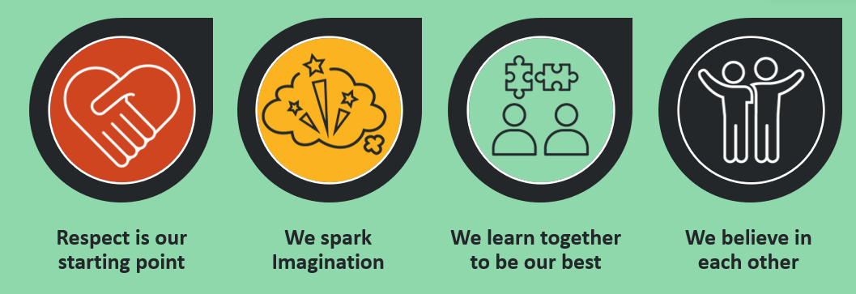

What you bring

Your responsibilities

System Administration
- Manage and maintain Deputy system configuration, including locations, teams, employee records, user roles, permissions and organisational structures.
- Support an accurate system set-up and ongoing maintenance in line with organisational requirements.
- Monitor system performance and identify opportunities to improve functionality, efficiency and user experience.
- Support upgrades, releases and system enhancements, including testing and deployment activities.

Rostering and Workforce Management
- Support managers in creating and maintaining compliant, efficient and person-centred rosters.
- Assist with the development and maintenance of roster templates and workforce planning tools.
- Monitor rostering data quality and support consistency of practice across services.
- Ensure system settings accurately reflect contracted hours, work patterns, overtime rules, leave arrangements and workforce policies.

User Support and Training
- Act as the first point of contact for Deputy-related queries.
- Troubleshoot and resolve day-to-day issues, escalating technical matters where appropriate.
- Provide guidance to colleagues at all levels, adapting support to different levels of digital confidence.
- Support in the development and maintenance of user guides and training materials. Support in the communication of updates to Managers

Data, Reporting and Integration
- Support the integrity and accuracy of workforce data held within Deputy.
- Assist with reporting requirements and management information requests.
- Monitor and support integrations between Deputy and other organisational systems, including HR, payroll and recruitment platforms.
- Identify and investigate data discrepancies, working collaboratively with relevant departments to resolve issues.

Continuous Improvement
- Work with operational and central support teams to identify opportunities to improve processes and system use.
- Contribute to digital transformation initiatives and wider workforce management improvements.
- Participate in user acceptance testing, pilot activities and implementation projects.
- Support the evaluation of system performance and recommend improvements based on user feedback and operational needs.

Compliance and Governance
- Ensure appropriate standards of confidentiality, information governance and data protection are maintained.
- Support compliance with organisational policies, employment legislation and workforce management procedures.
- Maintain accurate audit trails and records within the system.

Person Specification

Essential Experience and Knowledge
- Experience of administering workforce management, rostering, HR, payroll or similar business systems.
- Experience supporting system users and resolving operational issues.
- Good understanding of workforce data and reporting.
- Strong IT literacy and confidence working with multiple digital systems.
- Understanding of data protection, confidentiality and information governance principles.

Essential Skills
- Excellent attention to detail and commitment to data accuracy.
- Strong problem-solving and analytical skills.
- Ability to explain technical information clearly to non-technical audiences.
- Effective organisational and prioritisation skills.
- Strong written and verbal communication skills.
- Ability to build positive working relationships across departments.

Desirable
- Experience of Deputy workforce management software.
- Experience of system implementation or digital transformation projects.
- Knowledge of workforce planning and rostering within social care, health care or not-for-profit environments.
- Understanding of payroll processes and HR systems integration.

Personal Attributes
We are looking for someone who:
- Shares and demonstrates SeeAbility's values.
- Takes ownership and responsibility for delivering high-quality work.
- Is approachable, helpful and service-focused.
- Enjoys collaborating with colleagues and solving problems.
- Embraces change and seeks opportunities to improve ways of working.
- Has a commitment to inclusion, accessibility and supporting colleagues with differing levels of digital confidence.

Why Join SeeAbility?
This is an exciting opportunity to be part of a significant digital transformation programme that will directly support frontline services and improve the experience of colleagues across the organisation. You will play an important role in helping SeeAbility realise the benefits of its new workforce management system while supporting our mission of enabling people with disabilities to live ambitious lives.

