Job Title | Voice Co-Ordinator
Responsible to | Lesley Brown (Head of People Experience)
Responsible for | All Voice Model Meeting such as Taking Control, Family Forum, and Colleague Forum.

Role Purpose
To support the smooth running, coordination, administration, and communication of SeeAbility’s Voice Model, ensuring colleagues, people we support, families, and stakeholders are heard, connected, informed, and able to influence. This role combines coordination, creativity, and communication to strengthen engagement and foster a sense of community and belonging across SeeAbility.

Our Values

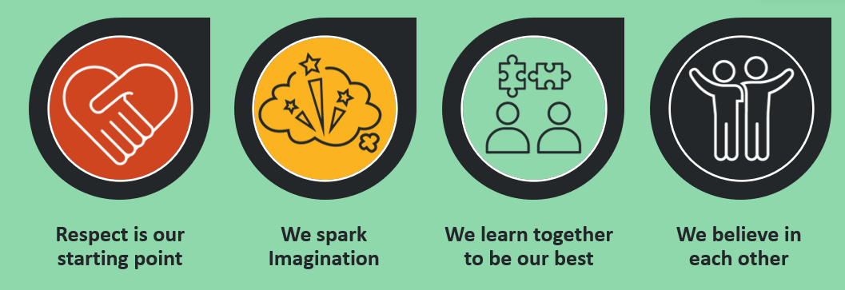

Your responsibilities on second page

Voice Coordination & Administration
- Coordinate and schedule all Voice Model meetings, including Taking Control, Family Forum, and Colleague Forum.
- Act as the central point for booking rooms, setting up virtual links, arranging accessibility needs, and ensuring all stakeholders are invited and prepared.
- Record accurate notes for every meeting, capturing key themes, actions, questions, and reflections.
- Maintain up-to-date records of: Forum membership and attendance; Questions submitted; Themes and issues raised across the three Voices; Bonus payments or rewards where applicable.
- Track and follow up on action items and outstanding issues to ensure accountability and closure.

Communication & Creative Engagement
- Use a mix of communication methods (email, articles, posters, visuals, stories, video snippets, intranet updates, etc.) to reach colleagues in accessible, engaging ways.
- Translate meeting outcomes, challenges, successes, and feedback into clear, approachable messages for different audiences.
- Spot links across the three Voice components and help connect stories, themes, and good practice.
- Draft, design, and support the preparation of presentations needed for Voice activities or wider engagement projects.
- Ensure all Voice meetings and events are organised, run smoothly, and, where required, are recorded and stored appropriately.
- Work closely with the Internal Communications Officer, contributing to campaigns, stories, updates, and communication planning as needed.

Data Management, Trends & Reporting
- Identify trends and themes across the three Voice forums by coding feedback into consistent categories (e.g., Care & Quality, Accessibility, Culture & Inclusion, Communication, Policy/Process, Training & Development, Environment/Estates, Digital & Tools, Safeguarding).
- Assess the impact and scope of issues (local / cross-homes/departments / systemic), highlighting emerging or declining patterns.
- Collate and produce reports for leadership: Quarterly Voice Trends & Themes Report for Senior Leadership Team; Annual Voice Report for Council, summarising year-on-year patterns, outcomes, and strategic recommendations.
- Maintain a central log and dashboard tracking issues raised, actions agreed, owners, deadlines, and status.
- Prepare short meeting summaries after each forum with key messages, decisions, actions, and items to escalate.
- Ensure records and evidence (notes, clips, attachments) are stored securely and are accessible in inclusive formats.

Skills & Experience
- Warm, approachable communicator able to engage people across different roles, backgrounds, and communication styles.
- Strong organiser with a flair for coordination, planning, and attention to detail.
- Confident in capturing notes and summarising conversations accurately and sensitively.
- Creative thinker who enjoys finding fresh, accessible ways to share information.
- Comfortable using (or learning) digital tools such as Teams, SharePoint, BLINK or AI.
- Able to handle confidential information with sensitivity and professionalism.
- Able to work on their own initiative, managing time, priorities, and tasks confidently without close supervision.
- Skilled at coordinating with many stakeholders, balancing different needs, communication styles, and expectations in a calm, organised, and patient way.
- A genuine passion for Voice, inclusion, and colleague experience.

What This Role Brings to SeeAbility
- Stronger, clearer, and more inclusive communication.
- Smooth, consistent delivery of Voice meetings and engagement activities.
- Better insights and connections across the Voice Model.
- More creative and accessible ways for colleagues to stay informed and feel part of our community.
- Support to ensure every colleague, family member, and person we support has a meaningful voice.
- Actionable insights and reports that inform leadership decisions and drive continuous improvement.

